API Data Fetcher with Search Functionality

Submitted By
Name: Goutham Reddy

1. Project Overview

Project Title
API Data Fetcher with Search Functionality

Objective
The objective of this project is to fetch data from a public REST API using Python's Requests library, parse JSON responses, and allow users to search and filter data efficiently through a command-line interface.

2. Technologies Used
- Python
- Requests Library
- JSON
- Git
- GitHub
- Visual Studio Code

3. Project Requirements
The project fulfills the following requirements:
- Fetch API data using Requests module
- Parse JSON response
- Implement search/filter functionality
- Handle exceptions properly
- Upload source code to GitHub

4. API Used
API Endpoint:
https://jsonplaceholder.typicode.com/users
Purpose:
This API provides sample user information including names, emails, phone numbers, websites, and addresses.

5. Source Code

Main Python Script
- Import and API Request
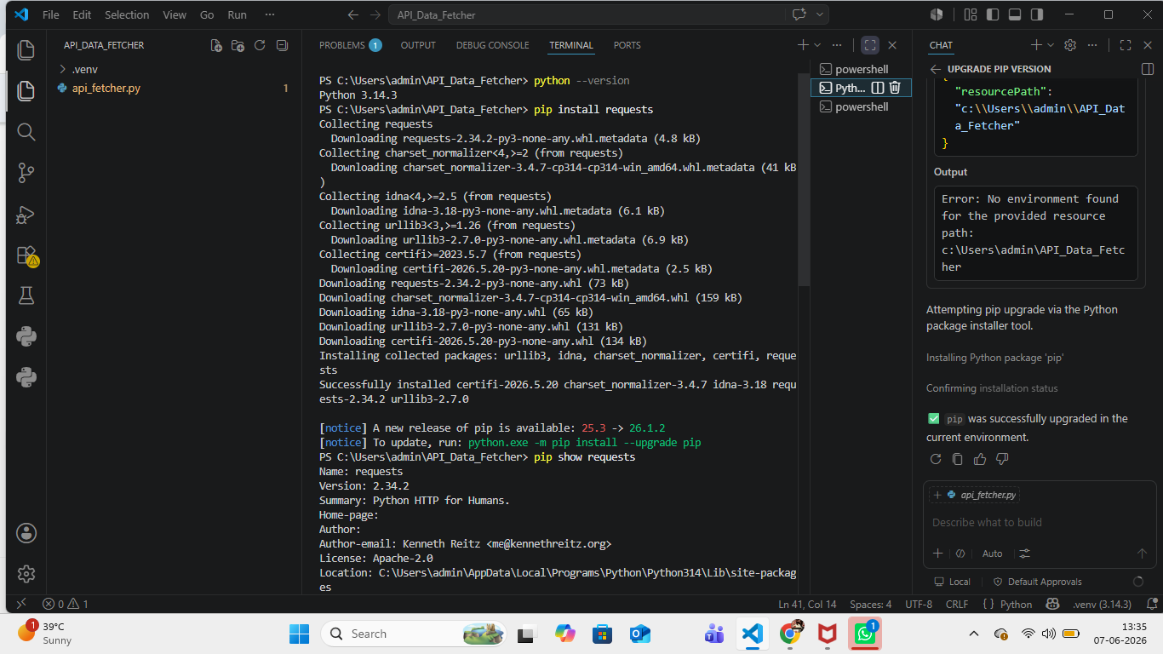

- JSON Parsing Logic
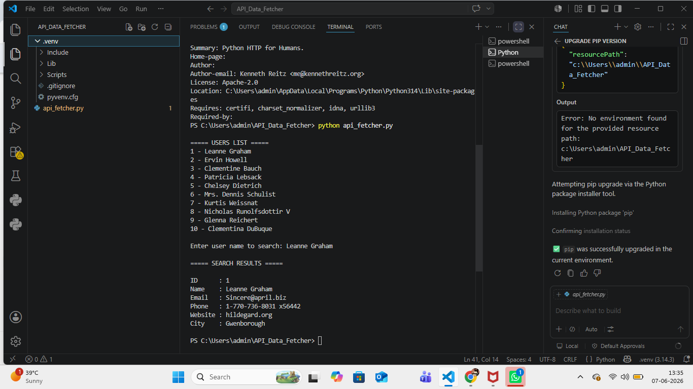
- Search Functionality
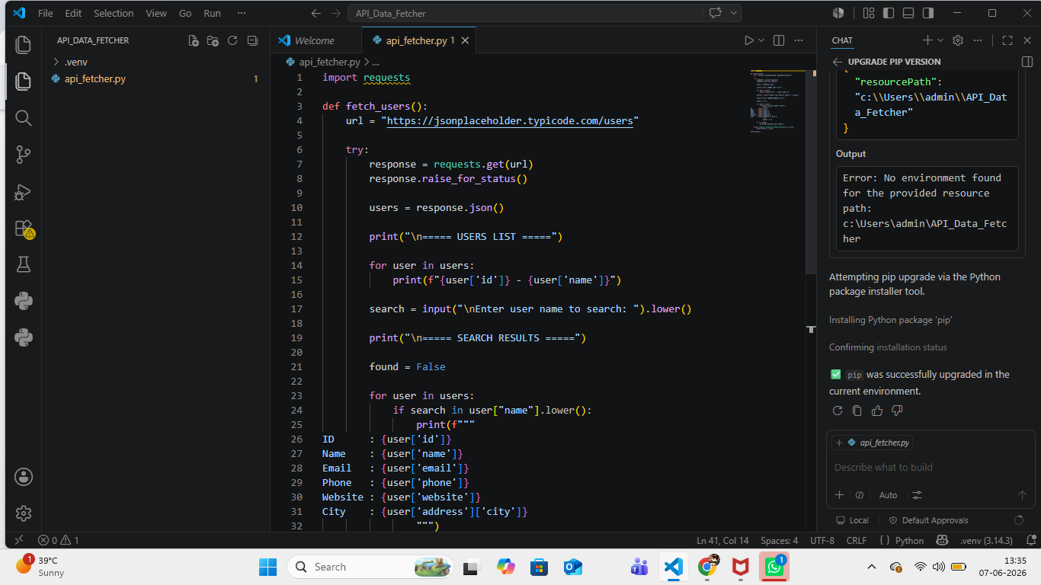

6. Program Output

User list : 

Screenshot 2: Search Result


Screenshot 3: No Results Found
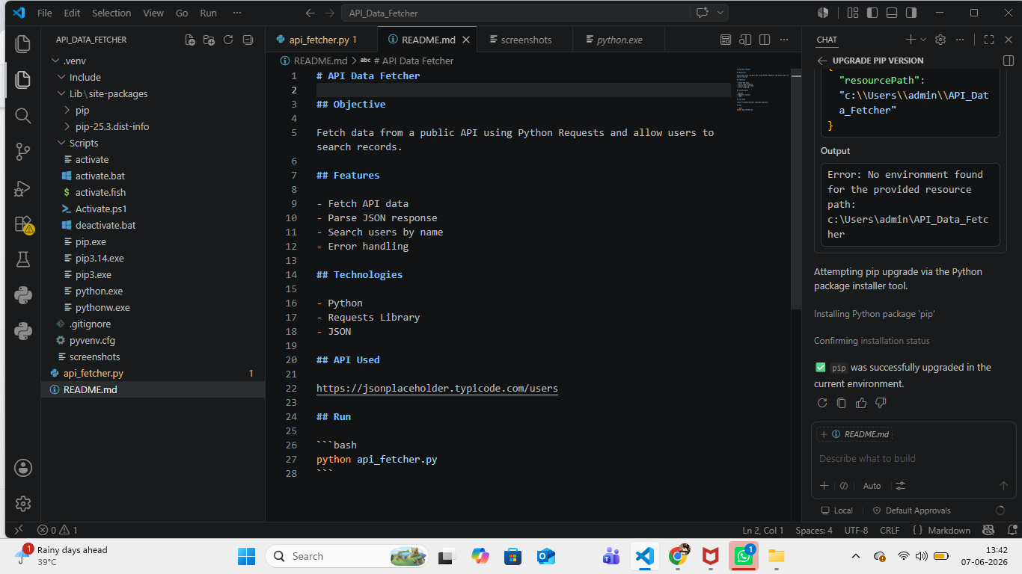

7. GitHub Repository
Repository Name: api-data-fetcher-python
GitHub Link: https://github.com/gouthamkandiwada/api-data-fetcher-python.git

8. Project Structure
API_Data_Fetcher/
├── api_fetcher.py
├── README.md
├── .gitignore
└── screenshots/
├── users_list.png

├── search_result.png

└── no_result.png

9. Features Implemented
- REST API Integration
- JSON Data Parsing
- Search and Filter Functionality
- Exception Handling
- Git Version Control
- GitHub Repository Management

10. Learning Outcomes
Through this project, I learned:
- How to consume REST APIs using Python
- How to work with JSON data
- How to implement search functionality
- How to handle API errors using exception handling
- How to manage projects using Git and GitHub

11. Conclusion
This project successfully demonstrates API integration using Python Requests. The application fetches user data from a public API, processes JSON responses, and provides search functionality for users. The project helped strengthen practical skills in Python programming, API consumption, JSON handling, and GitHub project management.
Thank You.

